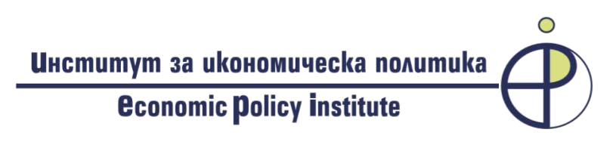
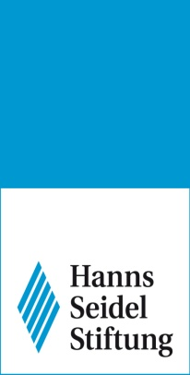

APPLICATION FORM

Third edition of the
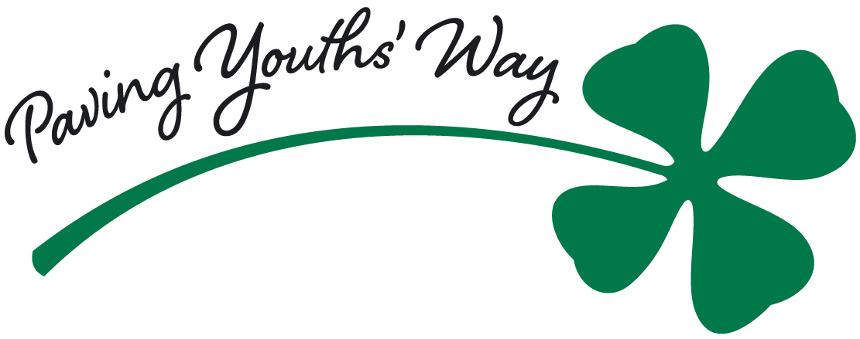

I N T E R N A T I O N A L
Y O U T H A C A D E M Y∗

on the topic:

Is my Europe the same as yours?

July 13 – 17, 2015
Pirin Hotel, Sandanski (Bulgaria)

Photo

First Name: |  |  |  | Last Name:
Date of Birth: |  | Nationality: |  |  | Gender: M / F
Phone: |  |  | E-mail:
Address:
City: |  |  |  | Country:
University: |  |  |  | Faculty:
University Major: |  |  |  | Year of Study:
Level of Study:  (undergraduate / graduate) |  |  |  | Type of Study  (full time / part time)
English language level
Please indicate the level of your English language proficiency:

 | Fair | Good | Very Good |  | Excellent | Certificate & Grade  (if available)
Reading
Speaking
Writing
Please describe your motivation for participation in the seminar – “Why are you the perfect candidate for the Paving Youths’ Way International Academy?” - maximum 100 words

Essay on the topic “My country in my Europe - Is my Europe the same as yours?” – maximum 350 words
Please comment on your expectations for the similarities and the differences in the perception of Europe in your own country compared to the other two states. Please bear in mind that you should make a short presentation during the seminar, based on your writing. You will have 2 to 5 minutes for presenting your vision on the topic. You could use different means of presentation – a PPP slide, poster, photo, collage, video, etc.
So be as creative, as possible!

Please, submit the application form to the attention of Ms. Desislava Petrova, Director “European Projects and Programmes” per e-mail: student_seminars@epi-bg.org no later than June 24th, 2015 (Wednesday).

 The PYW International Youth Academy is a project for Bulgarian, Greek and Romanian students in their last years of bachelor or master’s study.

